# Database Management System

# Introduction:

In the ever-evolving landscape of modern technologies, tons of data are present in social media or any other place. Millions of daily transactions are made so there is a need for a system that handles all the data efficiently and gives a better performance which are needed. So for this, the database management system was developed which took the place of physical file management and gives more advantages as compared to file management. In this assessment, the task is to build a hospital database that handles all the data related to a hospital and there are some queries for data insertion and selection these types of real-world scenarios are very beneficial for students as well to increase their confidence in working on real-world projects.

## Entity Relation Diagram:

The entity relation diagram is sometimes considered the backbone of the whole database because it contains all the information about developed entities and many information like the relations between entities (Rashkovits, R. and Lavy, I., 2021). The entity relation diagram for this database is shown below.

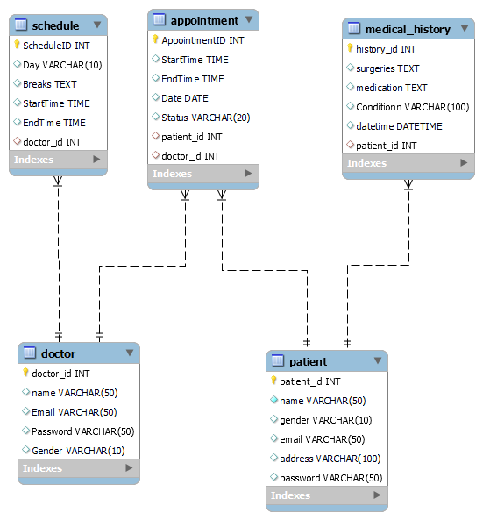

This diagram contains five database entities and their related attributes which help to build the database.

## Normalization:

### Patient Table:

This table is in 3NF because the table has a primary key (patient_id) and all the fields contain the atomic values, all the attributes are fully dependent on the primary key. And there are no transitive dependencies (Kraska, T., Alizadeh, M, ELT 2021).

### Doctor table :

This table is in 3NF because the table has a primary key (doctor_id) and all the fields contain the atomic values, all the attributes are fully dependent on the primary key. And there are no transitive dependencies.

### Schedule table :

This table is in 3NF because the table has a primary key (schdule_id) and all the fields contain the atomic values, all the attributes are fully dependent on the primary key. And there are no transitive dependencies.

### Appointment table :

This table is in 3NF because the table has a primary key (appointment_id) and all the fields contain the atomic values, all the attributes are fully dependent on the primary key. And there are no transitive dependencies.

### Medical_history table :

This table is in 3NF because the table has a primary key (history_id) and all the fields contain the atomic values, all the attributes are fully dependent on the primary key. And there are no transitive dependencies.

## Dependency Diagram:

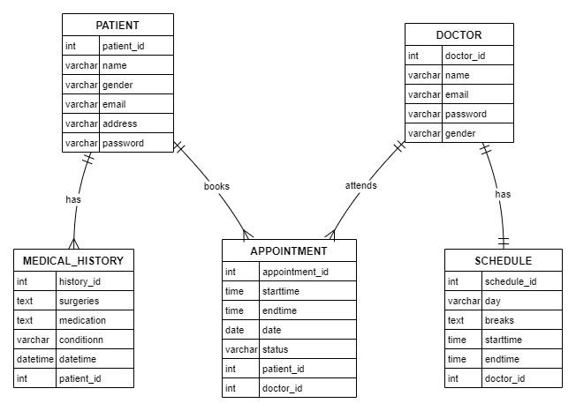

## Queries:

find the names of patients who have surgery.

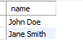

find the email address of the doctor who has an appointment.



find the address of the patient who has an appointment start time 09:00AM



find the start time of the patient’s appointment whose address is Sydney.



find the available doctor's name.



find the medical condition of a patient whose address is Sydney.



find the appointment date of a patient whose address is Sydney.



# Conclusion:

The database is created with the help of MySql workbench and in this report there is define all the content which is needed for the database including the Entity relation diagram, dependency diagram, and related question queries. After reading this comprehensive report the reader can easily understand the work and importance of databases in storing a bunch of data efficiently.

# References:

Kraska, T., Alizadeh, M., Beutel, A., Chi, E.H., Ding, J., Kristo, A., Leclerc, G., Madden, S., Mao, H. and Nathan, V., 2021. Sagedb: A learned database system.

Rashkovits, R. and Lavy, I., 2021. Mapping Common Errors in Entity Relationship Diagram Design of Novice Designers. *International Journal of Database Management Systems*, *13*(1), pp.1-19.